Website Survey

We want to know: “Do you use our website?” As we continue to grow and reach out into our community, our website can be an important tool for everyone. Now we want to see who in our congregation uses it. Please email Emily, [office@chapelhillumc.org](mailto:office@chapelhillumc.org), with your answer. Thank you!



Old Country Church Choir Gospel Concert

Our Music Minister, David Lee is participating in a Gospel Concert on October 29th at 6pm at First United Methodist Church in Irving. This should be a night of fun and joy as those Old Southern Gospel songs are performed. Please contact David Lee at [music@chapelhillumc.org](mailto:music@chapelhillumc.org) for more information.



***The Circlemaker***

**Follow along with the Pastor**

August 6th – Chapters 1-4

August 13th – Chapters 5-7

October 1st – Chapters 8-11

October 29th – Chapters 12-18

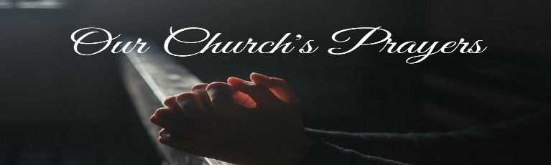

[www.chapelhillumc.org](http://www.chapelhillumc.org) | 972.241.3491 | [office@chapelhillumc.org](mailto:office@chapelhillumc.org)



The Gee Family

Archie Shivar

Betty Granbery

Martha Johnson

Barbara McConnell 7/9

The Family of Bob Bull

Phyllis Wenz

The Family of Teresa Gutridge – The Bandy Family

Those Affected by Hurricane Irma, Maria, and Harvey

Puerto Rico

These affected by the earthquakes in Mexico

Mary Francis Waggoner

Colton Graham – Ruth Fuls

JoNelle Lindh – Nancy Hartman 9/26

Jack Portman – Laurie Peake 9/26

Judy Laing – Terri Moore 9/26

Pat Moore 10/2

Marie Huie 10/1

Terry & Jackie Stogner – Meredith Moore 10/8

Joelle Gordon and Family – Kelly Patterson 10/8

Jessie Haynes – Roxanne Rawdon 10/10

**October 10, 2017**

🙣🙣🙣🙣🙣🙣

***Chapel Hill UMC*** Staff

Rev. Elzie Odom, Jr.

Senior Pastor

Melanie Willhite

Interim Family & Children’s Ministry

Brandi Loggins

Youth Ministry

David-Seung Lee

Worship & Music Ministry

Emily Hardwick

Office Manager



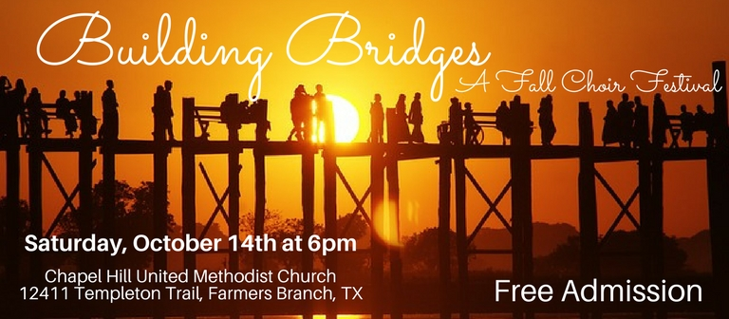

Building Bridges: A Fall Choir Festival

Come join us this Saturday, October 14th, at 6pm for our first Fall Choir Festival. If you are curious as to what performances will be featured, here is a sneak peek at our program! We can’t wait for you to come experience different cultures and their music as this festival creates ways for us all to build bridges between our neighbors.

O Happy Day …………………………………………………………………………….…………... Edwin R. Hawkins

German Song …………….……………......……...“Ich Liebe Dich”…………….………..…..…..… L.V. Beethoven

Spanish Song …………….….………….….…….. “Estrellita”……..……………....……...….… Manuel. M. Ponce

“Amazing Grace”…….………………………………………………………………….…………… arr. D. Funderburk

Korean Song ……………………......…….……...… “Arirang”……………….…………..…....….…..… Anonymous

Ave Verum Corpus K 618……………………………………........................……………..…………… W. A. Mozart

Nella Fantasia ……………………………………………………………….……...………....…… arr. Audrey Snyder

El Vito ……………..……………………………................……………….……………..……...….. arr. Emily Crocker

O Sole Mio ……………………………………………...………………...……………………...... arr. Jacob Narverud

Nearer My God to Thee ………………………………………………….……………………………….. S.F. Adams

Eine Kleine Nachtmusik KV 525 1 Movement ………………………………………..…………..... W. A. Mozart

You Raise Me Up …………………………….……………………………..…………...…………….. arr, Mark Hayes

O Danny Boy ……………………………………………………………….…………….…… arr. Joseph Flummerfelt

Praise His Holy Name ………………………………….......................……….……….…….………. Keith Hampton

There will be a reception to follow. Please make sure to take some tickets, invite your neighbors and friends, and talk about how amazing this Choir Festival will be. We hope to see you here!



**Chapel Hill United Methodist Church**

12411 Templeton Trail Farmers Branch, TX 75234

[www.chapelhillumc.org](http://www.chapelhillumc.org) [office@chapehillumc.org](mailto:office@chapehillumc.org)

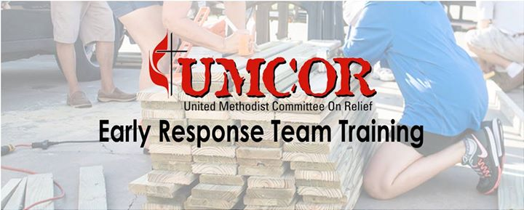

Emergency Response Training

When Hurricane Harvey hit, many of you asked what we could do. You collected money to send in support and continued to pray about those affected by the hurricane. We are going to be taking our next step by hosting an Emergency Response Training here on October 28th starting at 8:30 am. UMCOR also trains Early Response Teams, which are then deployed by United Methodist Volunteers in Mission (UMVIM) in times of need. These training programs and many more enable United Methodists in the US to bring hope to those who are suffering. We will be trained to continue helping with the rebuilding and cleanup of the Gulf Coast. We hope that you can make it!



Bob Bull

One of our dear congregant members, Bob Bull, departed from this world in the early morning this past Friday, October 6th. Many of you have been concerned about Bob after his cancer diagnosis and have been praying for healing and peace for his family. Thank you for all those thoughts and prayers and let us continue to keep his family in our prayers as they go through this time of grieving. The pastor has been talking with his family shorting following his passing, and we will be having a memorial service for him this coming Saturday, October 14th at 10 am. We hope that you will attend to celebrate his life and all that God has done through him.



October Ushers

1 - Robert Putnam, Kandy Burdette, Charlie Woods, Ruth Fuls  
8 - Sandy Fletcher, Pat Moore, Laurie Peake, Charles Loper  
15 - Craig Davis, Meredith Moore, Fred Maxwell, Mary Helen Fagan  
22 - Patsy Kaphehgst, Kermit Coggshall, Kevin and Kelly Patterson  
29 - Tom and Bisty Laney, Larry and Andrea Rains



October Monthly Outreach Project

This month we are collecting the most needed items for The Bridge, the homeless recovery center in downtown Dallas. They are always looking for men’s shoes and clothing (they accept women’s clothing too, but serve more men).

The hygiene items listed below are currently at the top of the needs list:

|  |  |
| --- | --- |
| * Mini Shampoo * Deodorant * Bug Spray * Soap * Razors * Reading Glasses (any strength) | * Travel Hand Sanitizer * Feminine Hygiene Items * Toothpaste & Toothbrushes * Mini Lotion * Plastic Ponchos * Wash Cloths |



Needs a Little Support

One of our members, Jonathon Fehlau, is currently going through boot camp with the Marines. If you could write him some letters of support to help encourage him through this time, he would appreciate it. His address is:

3rd BN Kiko Co. Plt. 3222

38990 Midway Ave.

San Diego, CA. 82140-3222

Jonathon Fehlau



|  |  |
| --- | --- |
| **Tuesday**, October 10 | |
| 6:30 PM | Worship |
| 7:30 PM | COM |
| **Wednesday**, October 11 | |
| 10:00 AM | Staff Meeting |
| 7:30 PM | Chancel Choir |
| **Thursday**, October 12 | |
| 8:00 AM | CLAY Leadership Teaching |
| 6:00 PM | Prayer Team |
| 7:00 PM | Weekly Bible Study |
| **Friday**, October 13 | |
| 10:00 AM | GISD Gym |
| **Saturday**, October 14 | |
| 10:00 AM | Bob Bull’s Memorial |
| 6:00 PM | Building Bridges: Fall Choir Festival |
| **Sunday**, October 15 | |
| CHILDREN'S SABBATH | |
| 8:45 AM | Chapel Bells |
| 9:15 AM | Sunday School |
| 10:30 AM | Worship |
| 11:30 AM | Children's Choir |
| 2:00 PM | Le Fe Que Vince Almundo |
| 5:00 PM | UMYF |
| **Monday**, October 16 | |
| 10:00 AM | Companions in Christ |
| 10:00 AM | GISD Gym |
| 11:30 AM | Seasons of Service |
| 11:30 AM | Prayer Group |
| **Tuesday**, October 17 | |
| 9:30 AM | Trustees Meeting |
| 7:00 PM | Finance Meeting |
| 7:30 PM | Church Council |
| **Wednesday**, October 18 | |
| 10:00 AM | Staff Meeting |
| 6:30 PM | Coin Club |
| 7:00 PM | Plus 4s Square Dancers |
| 7:30 PM | Chancel Choir |
| **Thursday**, October 19 | |
| 6:00 PM | Prayer Team |
| 7:00 PM | Weekly Bible Study |

**Please see our full calendar at:**

**https://www.chapelhillumc.org/getinvolved/calendar/**

CHANGE THE DATE

Trustees Work Day

The new date is Saturday, October 21st from 9:00 tp 1:00. Donuts will be furnished to entice you!

There will be a board in the narthex with a list of projects to be done. Find any of the Trustees for instruction, supplies, and equipment. There will be carts loaded with supplies in the narthex. We usually try to have work days twice a year, but did not have enough people to get everything done in the spring. Hopefully, we will have more volunteers this time and can get God’s home in shining and inviting condition. Many thanks to those who got a “head start.” See the rest of you on the 21st.

Trustees Co-Chair, Nancy Hartman

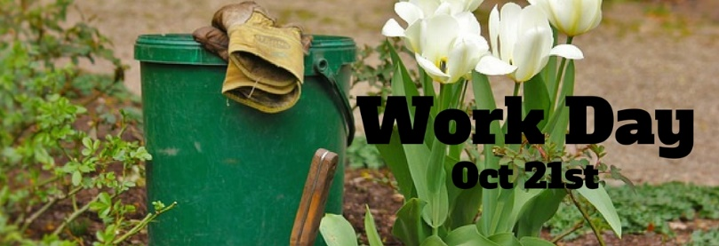

Children’s Sabbath

This Sunday we will be having our Children’s Sabbath. We hope that you will come out to hear from our Children and Interim Children’s Director, Melanie Willhite. It is always a joy to hear our children in worship and hope that you will come out to see them.

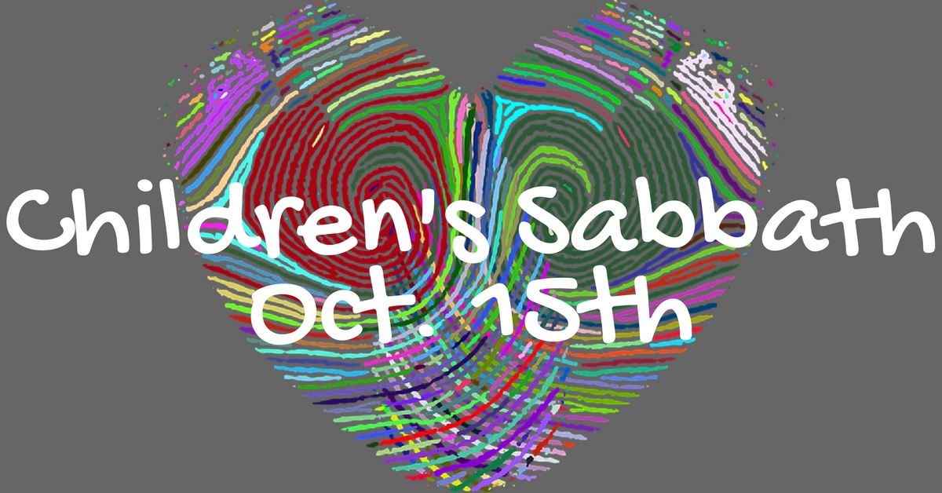

Want something in the Newsletter?

Send your newsletter article to [office@chapelhillumc.org](mailto:office@chapelhillumc.org) by 11am Monday.

Need to reserve a room or get on the calendar?

Please fill out an Event Request Form located on o our website: chapelhillumc.org, email [office@chapelhillumc.org](mailto:office@chapelhillumc.org), or in02 the folders on the table in the narthex

Want to have a bulletin insert or announcement slide?

Look at the standards and procedures in the folders on the narthex table and turn it in by 4pm Thursday.

Birthday Reminder: Please let our church office know your birthdate, mm/dd/yyyy, so your church family can acknowledge your special day.  **Your ‘year’ will remain private**: [**office@chapelhillumc.org**](mailto:office@chapelhillumc.org)



|  |  |  |
| --- | --- | --- |
| George Johnson 10/2 | Jin Kim 10/5 | Laura Broyles 10/7 |
| Nathan Moore 10/7 | Kim Rangel 10/10 | Dorlis Glass 10/14 |
| Kevin Patterson 10/14 | Kelly Patterson 10/15 | Iris Shivar 10/15 |
| Jonathan Sanborn 10/16 | Madeline Davis 10/18 | Wilson Moore 10/18 |
| Judy Bader 10/19 | Bob Bull 10/19 | Ana Laura Gamborino 10/19 |
| Edith Brooks 10/20 | Oscar Lopez 10/20 | Christopher Younger 10/20 |
| Peach Portman 10/23 | Robert Putnam 10/24 | Jim Hanigan 10/25 |
| Bert Bader 10/27 | Cindy Brown 10/28 | Jan Wooldridge 10/29 |
| Caroline Grevelle 10/30 | Joshua Kim 10/30 | Leslie Ochoa-Funez 10/30 |
|  |  |  |