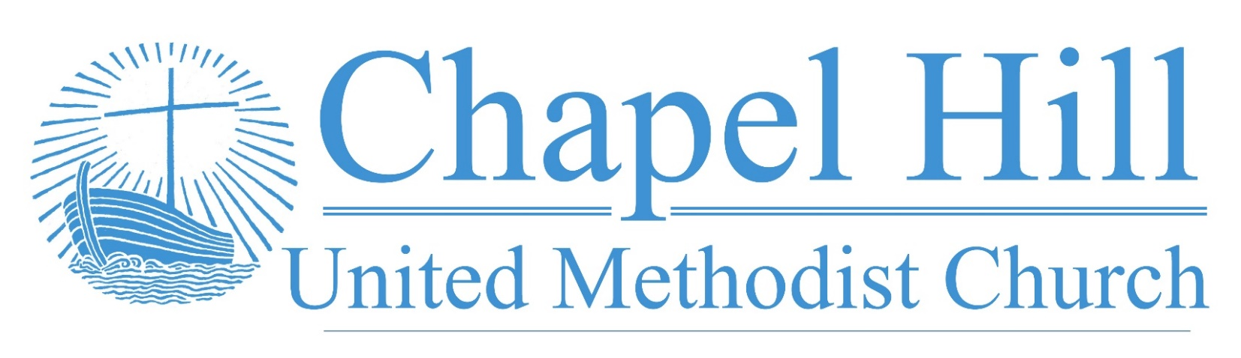

**Pastor’s Message**

CHUMC Family,

First, I want to offer an alert about an apparent phishing email. It says it is from me with the subject line, "DD Update." Do not open this email. Delete it immediately. If you can see the email address without opening it, the email is from wrship@virginmedia.com.

Next, I give great thanks for Chapel Hill UMC's members and constituents as we prepare for our annual charge conference. I know our Finance Coordinator Laurie Peak, Treasurer Jan Wooldridge, Trustee Coordinator Doc Putnam, SPR Coordinator Tom Wooldridge, COM Chair Melanie Willhite, and Historian Faye Chapman are working to help compile reports. Thank you.

There is a way you can help us prepare as well. When District Superintendent Rev. Edlen Cowley joins, he plans to hear from us collectively and individually, about our celebrations from 2022 and our vision for 2023. I will be visiting with Church Council and other groups about just these matters in the coming days. However, I invite you to share with me your personal celebrations and thoughts on our vision. You can email me at [pastor@chapelhillumc.org](mailto:pastor@chapelhillumc.org) or if you would like to chat about it, email and let me know and I will be in touch.

I know we have some matters to celebrate from this year and look forward to exploring with you about our vision for 2023.

Grace and peace,

Rev. J. D. Allen

**September 12, 2022**

🙣🙣🙣🙣🙣🙣🙣🙣🙣🙣

***Chapel Hill UMC***

Staff

Rev. J.D. Allen

Senior Pastor

Melissa Sky-Eagle

Worship & Music

Jim Hanigan

Building Manager



Birthday Reminder: Please let our church office know your birthdate, mm/dd/yyyy, so your church family can acknowledge your special day.  **Your ‘year’ will remain private**: [**office@chapelhillumc.org**](mailto:office@chapelhillumc.org)



|  |  |  |  |  |  |  |  |  |  |
| --- | --- | --- | --- | --- | --- | --- | --- | --- | --- |
| Walter Ochoa 9/11 | Beth Laney 9/14 |  |  |  |  | | | | |
| Beverly Holmes 9/15 | Angelo Ochoa 9/16 |  |  |  | | |  | |
| Nancy Hartman 9/17 | Laurie Willhite 9/17 |  |  |  | | |  | |
| Megan Willhite 9/17  Nancy Ochoa 9/23  Kaye Bandy 9/26 | Joanne Marchant 9/22  Roxanne Rawdon 9/23  Jessica Venancio 9/26 |  |  |  | | |  | |
| Emily Metzger 9/28 | Ruth Medcalf 9/29 |  |  | | |  | |  |
|  |  |  |  |  | | | |  |
|  |  |  |  |  | | | |  |
|  |  |  |  |  | | | |  |

**Prayer List**

|  |  |
| --- | --- |
| CHUMC Home Bound  The Gee Family  Tom Sanders  Judy Charvat  Beverly Holmes  Danny Halron  Donna Daggett  Tim Harrison  Jim Taylor  Grandma Gloria  Yvette's kids  Betty Garrison  Martha Johnson | Edrese Hanigan  Evelyn Womble  Ralph Minton  Kevin Patterson  Sam Orton  Archie Shivar  Gloria (Pinson) Ming  Lynda Mills  Juan Torres’ Co-Worker  Flood victims  Ukraine  Mass Shooting Victims |
|  | |



**Bible Year 2022 Readings**

|  |  |
| --- | --- |
| Monday, 9/12: | Matt. 19:1-20:34 |
| Tuesday, 9/13: | Matt. 21:1-46 |
| Wednesday, 9/14: | Matt. 22:1-23:29 |
| Thursday, 9/15: | Matt. 24:1-25:46 |
| Friday, 9/16: | Matt. 26:1-75 |
| Saturday, 9/17: | Matt. 27:1-28:20 |
| Sunday, 9/18: | Mark 1:1-3:35 |

**Join Us for Online Worship!**

**YouTube:** bit.ly/CHUMCYouTube

**Facebook:** www.facebook.com/  
chapelhillumc