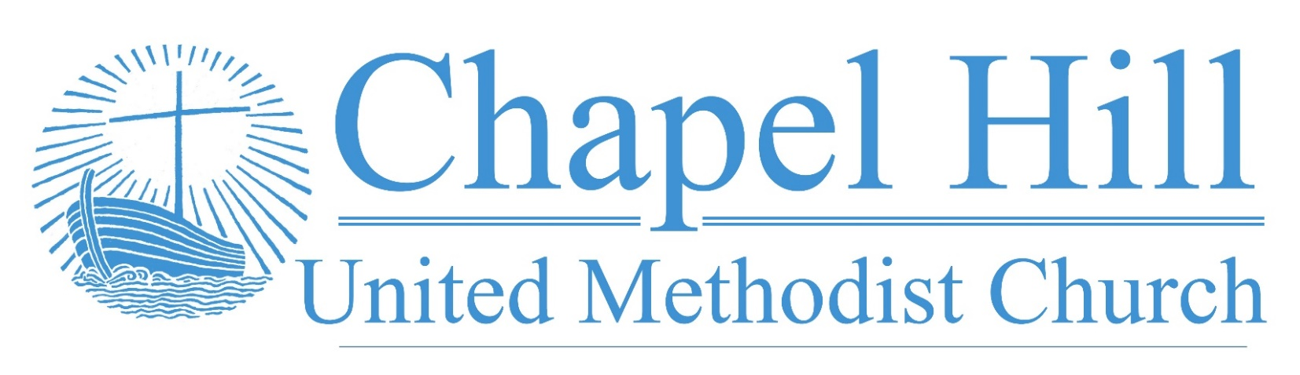

**Pastor’s Message**

CHUMC Family,

You may recall from last week's newsletter that I invited your input and mentioned I would be having conversations with some of the groups in our church about our celebrations from 2022 and our vision for 2023 as we prepare for charge conference this Sunday. Here is the input I have received from you here at Chapel Hill UMC.

We celebrated some of the simple things as we emerged from the pandemic, such as simply being alive and our church surviving, and our choir returning to the loft and the potluck returning on a quarterly basis. With this in mind, you celebrated the way the individuals and households within CHUMC maintained connection with one another and that, while our overall weekly attendance has declined due to the pandemic, it has stabilized and we have welcomed some new folks. You celebrated the quality of our worship as led by the choir and our talented choir director/accompanist Melissa Sky-Eagle and the monthly modern worship experience which arose out of our family ministry. You also celebrated that we remain a community center both for community groups such as the coin club and square dance groups and for those providing aid to those in need through Project Transformation and Sack Summer Hunger. We also celebrated the continuing mutually beneficial relationship with our tenants at the German International School of Dallas. Finally, we celebrated the work of discipling our young people through the return of children's worship, resulting in six of our children going to camp this summer followed by their amazing stockholder’s lunch in which we were able to hear about how they encountered the love of God at camp and we assembled the blessing bags for the homeless together.

In terms of vision, you mentioned getting back to the root of disciple making which is engaging new people. This includes focusing our outreach and hospitality efforts and discernment how an elderly local church might engage younger families. You also mentioned this will require us to get out of the building rather than focusing mainly on attractional events onsite. You also recognized young people have a tendency to rally around a cause, so that one way to connect with younger people who have reservations about church is to engage with them around causes we have in common as United Methodists.

(cont. on back)

**September 19, 2022**

🙣🙣🙣🙣🙣🙣🙣🙣🙣🙣

***Chapel Hill UMC***

Staff

Rev. J.D. Allen

Senior Pastor

Melissa Sky-Eagle

Worship & Music

Jim Hanigan

Building Manager



Birthday Reminder: Please let our church office know your birthdate, mm/dd/yyyy, so your church family can acknowledge your special day.  **Your ‘year’ will remain private**: [**office@chapelhillumc.org**](mailto:office@chapelhillumc.org)



|  |  |  |  |  |  |  |  |  |  |
| --- | --- | --- | --- | --- | --- | --- | --- | --- | --- |
| Walter Ochoa 9/11 | Beth Laney 9/14 |  |  |  |  | | | | |
| Beverly Holmes 9/15 | Angelo Ochoa 9/16 |  |  |  | | |  | |
| Nancy Hartman 9/17 | Laurie Willhite 9/17 |  |  |  | | |  | |
| Megan Willhite 9/17  Nancy Ochoa 9/23  Kaye Bandy 9/26 | Joanne Marchant 9/22  Roxanne Rawdon 9/23  Jessica Venancio 9/26 |  |  |  | | |  | |
| Emily Metzger 9/28 | Ruth Medcalf 9/29 |  |  | | |  | |  |
|  |  |  |  |  | | | |  |
|  |  |  |  |  | | | |  |
|  |  |  |  |  | | | |  |

I, along with you, am thankful for everything we have to celebrate this year, despite the trials of the last two and a half years. And I anticipate a hopeful future as we build on our initial vision and seek to live into that vision together.

Grace and peace,

Rev. J. D. Allen

**Prayer List**

|  |  |
| --- | --- |
| CHUMC Home Bound  The Gee Family  Tom Sanders  Judy Charvat  Beverly Holmes  Danny Halron  Donna Daggett  Tim Harrison  Jim Taylor  Grandma Gloria  Yvette's kids  Betty Garrison  Martha Johnson  Edrese Hanigan | Evelyn Womble  Ralph Minton  Kevin Patterson  Sam Orton  Archie Shivar  Gloria (Pinson) Ming  Lynda Mills  Juan Torres’ Co-Worker Jerry  Juan Torres’ Co-Worker John  Flood victims  Jennie Leamons  Ruth Fuls  Ukraine  Mass Shooting Victims |
|  | |

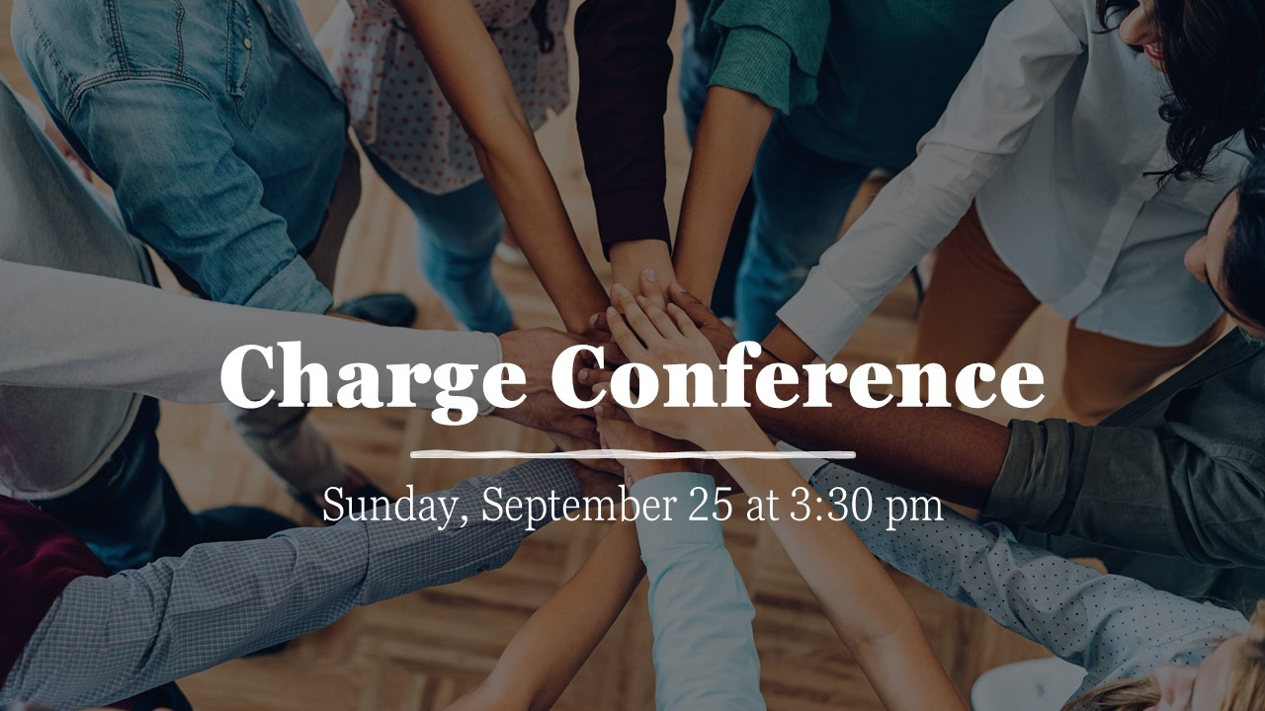

**Bible Year 2022 Readings**

|  |  |
| --- | --- |
| Monday, 9/19: | Mark 4:1-5:43 |
| Tuesday, 9/20: | Mark 6:1-56 |
| Wednesday, 9/21: | Mark 7:1-8:38 |
| Thursday, 9/22: | Mark 9:1-10:45 |
| Friday, 9/23: | Mark 10:46-12:34 |
| Saturday, 9/24: | Mark 12:35-13:37 |
| Sunday, 9/25: | Mark 14:1-72 |

**Join Us for Online Worship!**

**YouTube:** bit.ly/CHUMCYouTube

**Facebook:** www.facebook.com/  
chapelhillumc