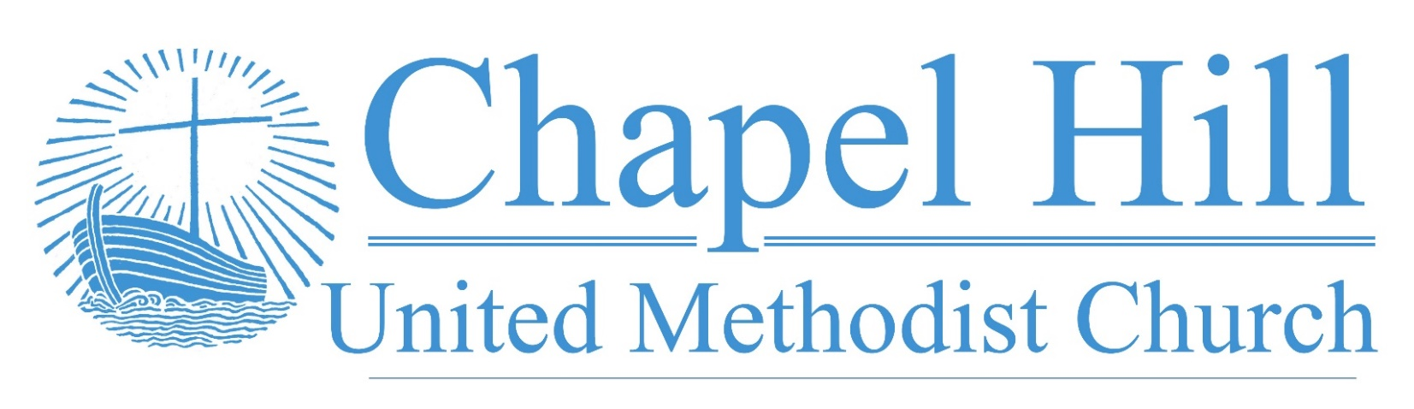

**Pastor’s Message**

CHUMC Family,

In recent weeks, our main entrance has been inaccessible because the latching mechanism broke on the door leaving the latch locked in place. This resulted in us using the Fellowship Hall to enter the building. It appeared it was going to be several more weeks to a couple of months to get the needed parts or thousands of dollars for a door company to repair it. It was a strange optic for there to be such difficulty in entering the church.

Thankfully, our handyman Alan Fisher was able to work with local locksmiths to get a new panic bar and door handle located and installed so that the door could be repaired much sooner and at less cost. As a result, the main entrance has regained its hospitality. Anyone who comes may find entry to our church.

Now consider the hospitality of our God in Christ as Jesus explains in Matthew 7:

7 “Ask, and it will be given to you; search, and you will find; knock, and the door will be opened for you. 8 For everyone who asks receives, and everyone who searches finds, and for everyone who knocks, the door will be opened. 9 Is there anyone among you who, if your child asked for bread, would give a stone? 10 Or if the child asked for a fish, would give a snake? 11 If you, then, who are evil, know how to give good gifts to your children, how much more will your Father in heaven give good things to those who ask him!

 Our God is a hospitable God, just waiting to take us in if we will simply knock on the door and ask to enter the household. Life may be disappointing, daunting, or even, frightening. Yet there is shelter in God's presence. All we have to do is go to God's porch in faith and knock.

Grace and peace,

Rev. J. D. Allen

**September 26, 2022**

🙣🙣🙣🙣🙣🙣🙣🙣🙣🙣

***Chapel Hill UMC***

Staff

Rev. J.D. Allen

Senior Pastor

Melissa Sky-Eagle

Worship & Music

Jim Hanigan

Building Manager



Birthday Reminder: Please let our church office know your birthdate, mm/dd/yyyy, so your church family can acknowledge your special day.  **Your ‘year’ will remain private**: [**office@chapelhillumc.org**](mailto:office@chapelhillumc.org)



|  |  |  |  |  |  |  |  |  |  |
| --- | --- | --- | --- | --- | --- | --- | --- | --- | --- |
| Walter Ochoa 9/11 | Beth Laney 9/14 |  |  |  |  | | | | |
| Beverly Holmes 9/15 | Angelo Ochoa 9/16 |  |  |  | | |  | |
| Nancy Hartman 9/17 | Laurie Willhite 9/17 |  |  |  | | |  | |
| Megan Willhite 9/17  Nancy Ochoa 9/23  Kaye Bandy 9/26 | Joanne Marchant 9/22  Roxanne Rawdon 9/23  Jessica Venancio 9/26 |  |  |  | | |  | |
| Emily Metzger 9/28 | Ruth Medcalf 9/29 |  |  | | |  | |  |
|  |  |  |  |  | | | |  |
|  |  |  |  |  | | | |  |
|  |  |  |  |  | | | |  |

**Metrocrest Services Peanut Butter Drive**

Please join us as we collect peanut butter donations through the month of October to help the food pantry at Metrocrest Services restock their dwindling supply and out neighbors can spread some love on their toast.

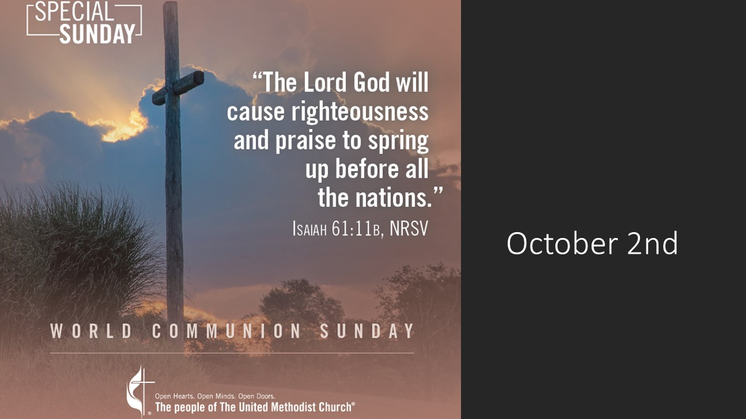

**Prayer List**

|  |  |
| --- | --- |
| CHUMC Home Bound  The Gee Family  Tom Sanders  Judy Charvat  Beverly Holmes  Danny Halron  Donna Daggett  Tim Harrison  Jim Taylor  Grandma Gloria  Yvette's kids  Betty Garrison  Martha Johnson  Edrese Hanigan  Evelyn Womble  Ralph Minton  Kevin Patterson | Sam Orton  Archie Shivar  Gloria (Pinson) Ming  Lynda Mills  Juan Torres’ Co-Worker Jerry  Juan Torres’ Co-Worker John  Jennie Leamons  Ruth Fuls  Margaret Garneaux  Josie Wilmoth  Kandy Burdette  Judy Bull  Steph Rayes  Anne Richardson’s family  Flood victims  Ukraine  Mass Shooting Victims |
|  | |

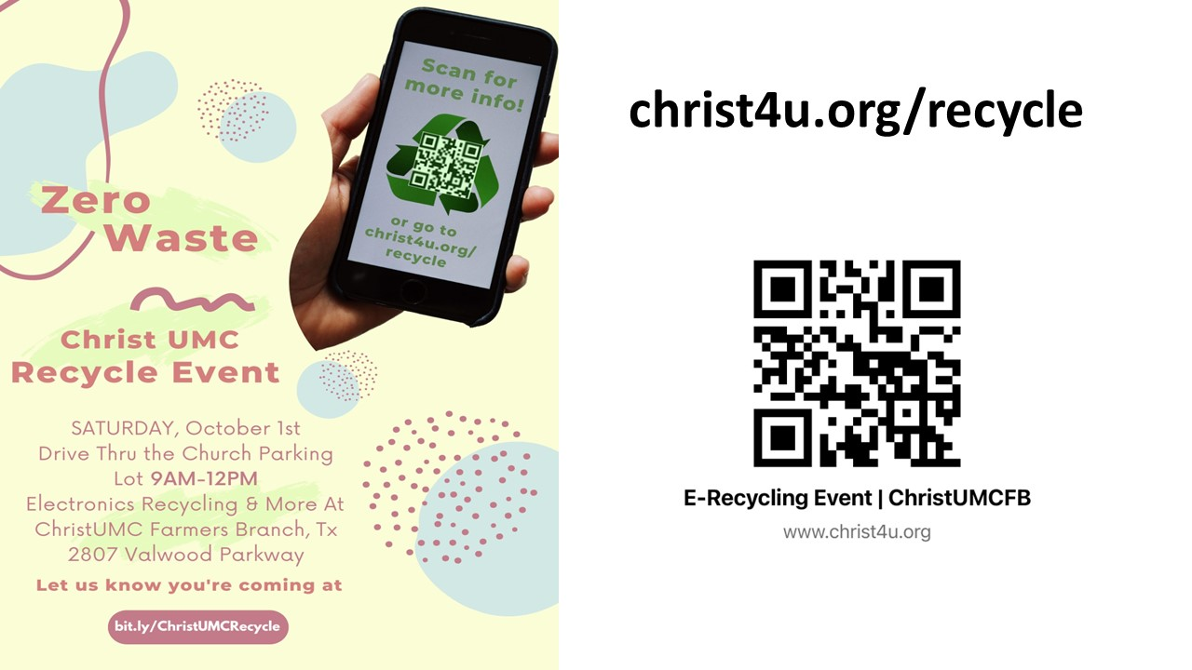

**Bible Year 2022 Readings**

|  |  |
| --- | --- |
| Monday, 9/26: | Mark 15:1-16:20 |
| Tuesday, 9/27: | Luke 1:1-80 |
| Wednesday, 9/28: | Luke 2:1-52 |
| Thursday, 9/29: | Luke 3:1-4:13 |
| Friday, 9/30: | Luke 4:14-5:39 |
| Saturday, 10/1: | Luke 6:1-49 |
| Sunday, 10/2: | Luke 7:1-8:39 |

**Join Us for Online Worship!**

**YouTube:** bit.ly/CHUMCYouTube

**Facebook:** www.facebook.com/  
chapelhillumc