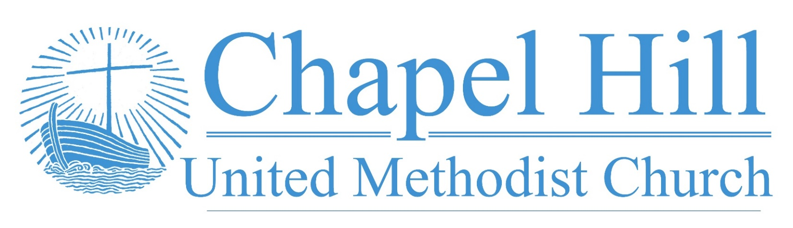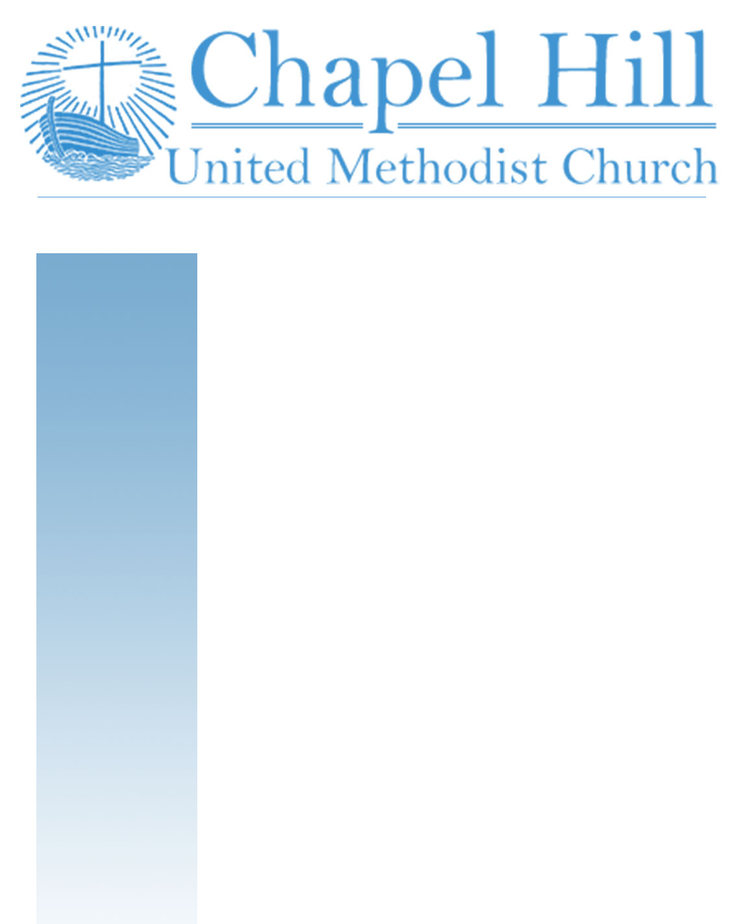

**Pastor’s Message**

CHUMC Family,

I have a couple of exciting bits of news to share with you as this week commences after the holiday.

First, This past week marked the beginning of Adam Richards internship. Adam will mostly be doing their internship work continuing to plant and grow the Synergy Wesley student ministry at the Brookhaven campus of Dallas College. However, we will see them here on Sundays helping in worship and preaching about once a month. It is an honor to be a part of the discernment process of someone who has sensed a call to ordained ministry as their supervising pastor. I am grateful for Vin Scheihagen, Kandy Burdette, and Lee Wilhite who have agreed to be a part of Adam's Lay Training Committee. You, too, can be a valued part of Adam's internship by being in prayer for them during this time of training and education with your prayer and support during this 2022-2023 school year.

Next, we get to celebrate the return of Project Transformation After School this Thursday. It is a privilege to be able to provide further support for this ministry and for the families whose children benefit from this program. There will be some volunteer opportunities available, so keep your eyes and ears peeled. We will also commit to be in prayer for Project Transformation this school year.

Supporting these two areas of ministry enables us to expand our generational reach here at Chapel Hill UMC. I know we can look forward to experiencing the work of the Holy Spirit and God's grace as we support Adam, Synergy Wesley, and Project Transformation.

Grace and peace,

Rev. J. D. Allen

**September 6, 2022**

🙣🙣🙣🙣🙣🙣🙣🙣🙣🙣

***Chapel Hill UMC***

Staff

Rev. J.D. Allen

Senior Pastor

Melissa Sky-Eagle

Worship & Music

Jim Hanigan

Building Manager



Birthday Reminder: Please let our church office know your birthdate, mm/dd/yyyy, so your church family can acknowledge your special day.  **Your ‘year’ will remain private**: [**office@chapelhillumc.org**](mailto:office@chapelhillumc.org)



|  |  |  |  |  |  |  |  |  |  |
| --- | --- | --- | --- | --- | --- | --- | --- | --- | --- |
| Walter Ochoa 9/11 | Beth Laney 9/14 |  |  |  |  | | | | |
| Beverly Holmes 9/15 | Angelo Ochoa 9/16 |  |  |  | | |  | |
| Nancy Hartman 9/17 | Laurie Willhite 9/17 |  |  |  | | |  | |
| Megan Willhite 9/17  Nancy Ochoa 9/23  Kaye Bandy 9/26 | Joanne Marchant 9/22  Roxanne Rawdon 9/23  Jessica Venancio 9/26 |  |  |  | | |  | |
| Emily Metzger 9/28 | Ruth Medcalf 9/29 |  |  | | |  | |  |
|  |  |  |  |  | | | |  |
|  |  |  |  |  | | | |  |
|  |  |  |  |  | | | |  |

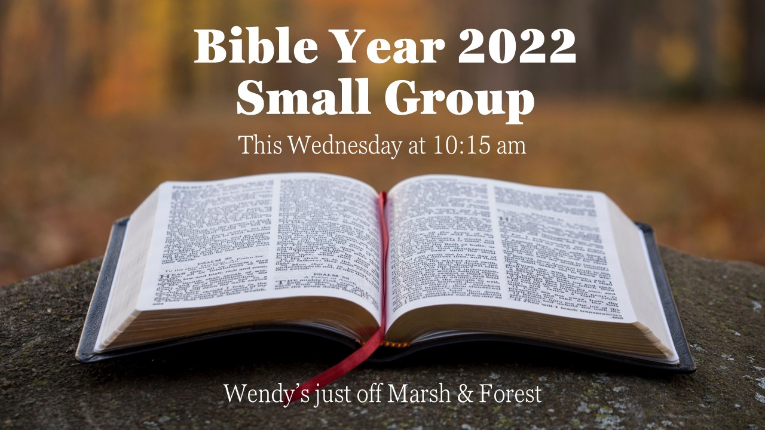

**Prayer List**

|  |  |
| --- | --- |
| CHUMC Home Bound  The Gee Family  Tom Sanders  Judy Charvat  Beverly Holmes  Danny Halron  Donna Daggett  Tim Harrison  Jim Taylor  Grandma Gloria  Yvette's kids  Betty Garrison | Martha Johnson  Edrese Hanigan  Evelyn Womble  Ralph Minton  Kevin Patterson  Sam Orton  Archie Shivar  Gloria (Pinson) Ming  Lynda Mills  Flood victims  Ukraine  Mass Shooting Victims |
|  | |

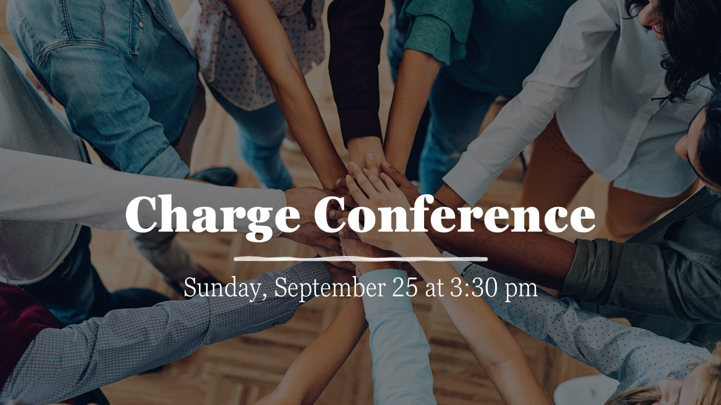

**Bible Year 2022 Readings**

|  |  |
| --- | --- |
| Monday, 9/5: | Matt. 6:1-34 |
| Tuesday, 9/6: | Matt. 7:1-8:34 |
| Wednesday, 9/7: | Matt. 9:1-10:42 |
| Thursday, 9/8: | Matt. 11:1-12:50 |
| Friday, 9/9: | Matt. 13:1-58 |
| Saturday, 9/10: | Matt. 14:1-15:39 |
| Sunday, 9/11: | Matt. 16:1-18:35 |

**Join Us for Online Worship!**

**YouTube:** bit.ly/CHUMCYouTube

**Facebook:** www.facebook.com/  
chapelhillumc