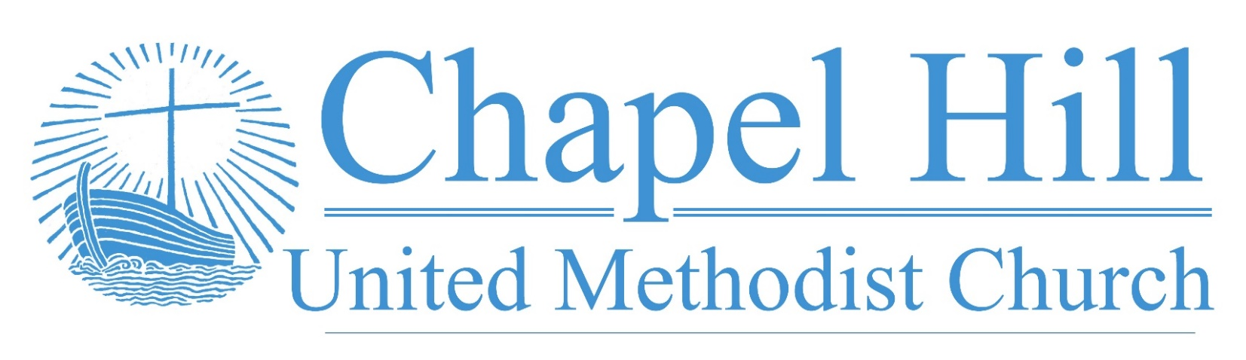

**Weekly Message**

CHUMC Family,

Laity and Children's Sunday are combining this year for the first time and we are excited about it!  Paige Tully Chenault will be our guest speaker telling us about The Birthday Project which she founded 10+ years ago.

The Birthday Project has birthday parties for underprivileged children once a month.  Some of these children have never had a birthday party. Our church and our children and youth have supported this project in the past by bringing birthday supplies like plates, cups napkins etc.

I hope again we can support this wonderful cause! We will have a love offering on Sunday, October 30 benefiting the Birthday Project. Please join us we celebrate with Paige and our church.

Learn more about the Birthday Party Project here:

<https://www.thebirthdaypartyproject.org/>

**October 10, 2022**

🙣🙣🙣🙣🙣🙣🙣🙣🙣🙣

***Chapel Hill UMC***

Staff

Rev. J.D. Allen

Senior Pastor

Melissa Sky-Eagle

Worship & Music

Jill Cox

Office Manager

Jim Hanigan

Building Manager



Birthday Reminder: Please let our church office know your birthdate, mm/dd/yyyy, so your church family can acknowledge your special day.  **Your ‘year’ will remain private**: [**office@chapelhillumc.org**](mailto:office@chapelhillumc.org)



|  |  |  |  |  |  |  |  |  |  |
| --- | --- | --- | --- | --- | --- | --- | --- | --- | --- |
| George Johnson 10/2 | Iris Shivar 10/15 |  |  |  |  | | | | |
| Madeline Davis 10/18 | Wilson Moore 10/18 |  |  |  | | |  | |
| Oscar Lopez 10/20 | Christopher Younger 10/20 |  |  |  | | |  | |
| Wesley Freeman 10/21  Jim Hanigan 10/25 | Robert Putnam 10/24  Jan Wooldridge 10/29 |  |  |  | | |  | |
| Leslie Ochoa-Funez 10/30 | Junior DeLeon 10/30 |  |  | | |  | |  |
| Denise Maxwell 10/31 |  |  |  |  | | | |  |
|  |  |  |  |  | | | |  |
|  |  |  |  |  | | | |  |

**Metrocrest Services Peanut Butter Drive**

Please join us as we collect peanut butter donations through the month of October to help the food pantry at Metrocrest Services restock their dwindling supply and out neighbors can spread some love on their toast.

**Church Council**

Our next Church Council meeting will be Monday, October 10, 2022. Church Council will continue to build the vision for 2023 which we began in our reflections for Charge Conference among discussing other important items.

**Project Transformation Family Fun Night**

The first Family Fun Night for the after school kids this school year is Thursday, October 20. This is CHUMC’s month to provide the meal. Please see Melanie Willhite to find out how you can help with the meal that night.

**Prayer List**

|  |  |
| --- | --- |
| CHUMC Home Bound  The Gee Family  Tom Sanders  Judy Charvat  Beverly Holmes  Danny Halron  Donna Daggett  Tim Harrison  Jim Taylor  Grandma Gloria  Yvette's kids  Betty Garrison  Martha Johnson  Edrese Hanigan  Evelyn Womble  Ralph Minton  Kevin Patterson  Sam Orton | Archie Shivar  Gloria (Pinson) Ming  Lynda Mills  Juan Torres’ Co-Worker Jerry  Juan Torres’ Co-Worker John  Jennie Leamons  Ruth Fuls  Margaret Garneaux  Josie Wilmoth  Kandy Burdette  Judy Bull  Steph Rayes  Anne Richardson’s family  Juan Torres’ friend Issic  Juan Torres’ friend Ray  Hurricane Ian victims  Ukraine  Mass Shooting Victims |
|  | |

**Bible Year 2022 Readings**

|  |  |
| --- | --- |
| Monday, 10/10: | Luke 20:1-21:28 |
| Tuesday, 10/11: | Luke 22:1-71 |
| Wednesday, 10/12: | Luke 23:1-56 |
| Thursday, 10/13: | Luke 24:1-53 |
| Friday, 10/14: | John 1:1-2:12 |
| Saturday, 10/15: | John 2:13-3:36 |
| Sunday, 10/16: | John 4:1-54 |

**Join Us for Online Worship!**

**YouTube:** bit.ly/CHUMCYouTube

**Facebook:** www.facebook.com/  
chapelhillumc