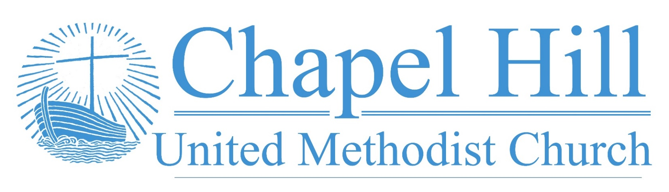

**Pastor’s Message**

CHUMC Family,

I write today to inform you that we have had the pleasure of hiring a new office manager, so please offer your heartiest hospitality to Jill Cox whenever you may have the opportunity.

Jill lives in Carrollton with her husband Mark, who works in restaurant construction. She currently also works as a notary. She comes to CHUMC with plentiful office work experience, including two previous stints in United Methodist churches. It is our pleasure to have Jill join our staff.

With that in mind, we have a couple of matters to remind you of going forward. First, our current office hours are Monday through Thursday, 10 am to 2 pm. If you or someone you know needs to contact the church office, this is when you will be able to reach Jill. Please note it is best to call ahead or email Jill and/or me if you need to meet with me as my service to CHUMC, the North Texas Conference, and community outreach may take me off campus at times. However, I am also available for appointments outside of office hours if you will call Jill to set that up.

Also, with our calendar slowly becoming more active, it is important to note that if you have an event to schedule at the church, you need to complete an event request form either at the office or on our website. If you want said event to be promoted through CHUMC channels or you have some other announcement to make, please review our CHUMC Communications Plan, which is on the table outside the main office, in detail so you may ensure your announcement is made in a timely fashion. It is important to note, within this plan, that anything you are submitting for promotion must be received by Tuesday to be included in our materials for the following week.

Things are slowly getting back to normal and it is a reassuring reality to be able to say that. We thank you for your cooperation as we journey into a new era at CHUMC.

***Grace and peace,***

***Rev. J.D. Allen***

**October 17, 2022**

🙣🙣🙣🙣🙣🙣🙣🙣🙣🙣

***Chapel Hill UMC***

Staff

Rev. J.D. Allen

Senior Pastor

Melissa Sky-Eagle

Worship & Music

Jill Cox

Office Manager

Jim Hanigan

Building Manager



**Join Us for Online Worship!**

**YouTube:** bit.ly/CHUMCYouTube

**Facebook:** www.facebook.com/  
chapelhillumc

|  |  |  |  |  |  |  |  |  |  |
| --- | --- | --- | --- | --- | --- | --- | --- | --- | --- |
| George Johnson 10/2 | Iris Shivar 10/15 |  |  |  |  | | | | |
| Madeline Davis 10/18 | Wilson Moore 10/18 |  |  |  | | |  | |
| Oscar Lopez 10/20 | Christopher Younger 10/20 |  |  |  | | |  | |
| Wesley Freeman 10/21  Jim Hanigan 10/25 | Robert Putnam 10/24  Jan Wooldridge 10/29 |  |  |  | | |  | |
| Leslie Ochoa-Funez 10/30 | Junior DeLeon 10/30 |  |  | | |  | |  |
| Denise Maxwell 10/31 |  |  |  |  | | | |  |
|  |  |  |  |  | | | |  |
|  |  |  |  |  | | | |  |

Birthday Reminder: Please let our church office know your birthdate, mm/dd/yyyy, so your church family can acknowledge your special day.  **Your ‘year’ will remain private**: [**office@chapelhillumc.org**](mailto:office@chapelhillumc.org)



**Laity & Children’s Sunday**

Our children and youth are very excited to partner with our church members to lead worship on Sunday, October 30! They are also excited about supporting the Birthday Party Project! Do you know we can all help support their effort over the next two weeks? We plan to gather donations so our children can shop on the Birthday Party Project’s Amazon wishlist for things like dolls, bracelet making sets, headphones, etc. Please be on the lookout for a youth or child of CHUMC to ask for your support!

**Bible Year 2022 Readings**

|  |  |
| --- | --- |
| Tue., Oct. 18 | : John 6:22-7:9 |
| Wed., Oct. 19 | : John 7:10-8:59 |
| Thurs., Oct. 20 | : John 9:1-10:42 |
| Fri., Oct. 21 | : John 11:1-12:50 |

Sat. Oct. 22:Mark 9:1-10:45

Sun. Oct. 23: Mark 10:46-12:34

Mon. Oct.24: Mark 12:35-13:37

|  |  |
| --- | --- |
|  |  |
|  |  |

**Metrocrest Services Peanut Butter Drive**

Please join us as we collect peanut butter donations through the month of October to help the food pantry at Metrocrest Services restock their dwindling supply and out neighbors can spread some love on their toast.

**Project Transformation Family Fun Night**

The first Family Fun Night for the after school kids this school year is Thursday, October 20. This is CHUMC’s month to provide the meal. Please see Melanie Willhite to find out how you can help with the meal that night.

**All Saints Day**

Sunday, November 6

**Thanksgiving Feast**  
We are beginning to plan for our Thanksgiving Feast and need some information from the congregation.  It will be right after worship on the Sunday before Thanksgiving (Nov. 20th).  It will help tremendously if you let us know if you are coming and how many quests you will bring.  It will also help us if you know you will NOT be there.

**Prayer List**

|  |  |
| --- | --- |
| CHUMC Home Bound  The Gee Family  Tom Sanders  Judy Charvat  Beverly Holmes  Danny Halron  Donna Daggett  Tim Harrison  Jim Taylor  Grandma Gloria  Yvette's kids  Betty Garrison  Martha Johnson  Edrese Hanigan  Evelyn Womble | Ralph Minton  Kevin Patterson  Gloria (Pinson) Ming  Kandy Burdette  Judy Bull  Steph Rayes  Anne Richardson’s family  Juan Torres’ friend Issic  Juan Torres’ friend Ray  Family of Archie Shivar  David Loper  Hurricane Ian victims  Ukraine  Mass Shooting Victims |
|  | |