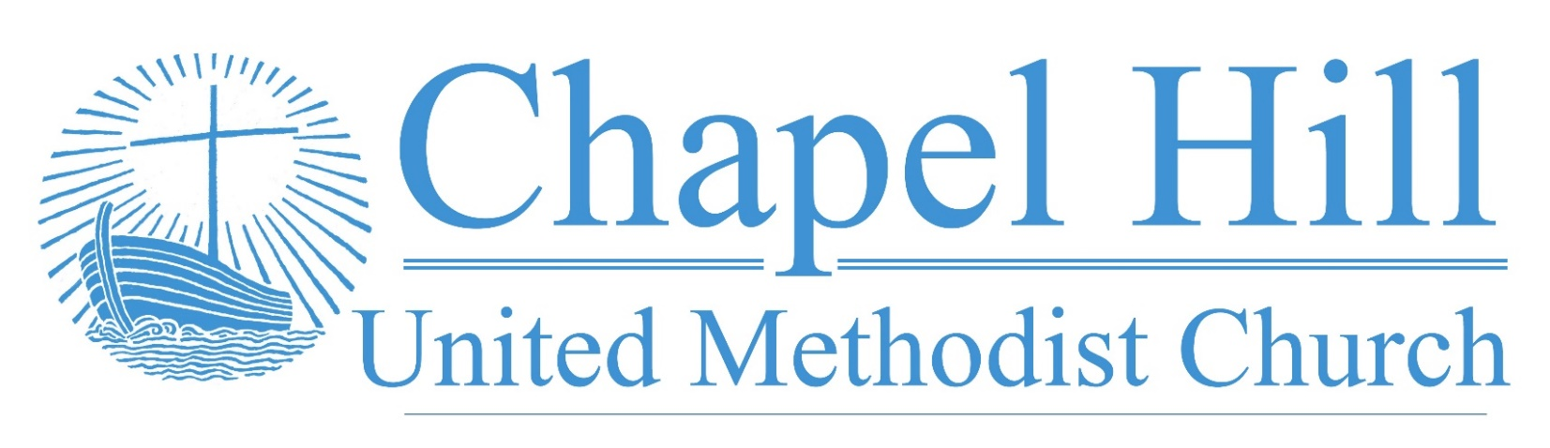

**Pastor’s Message**

CHUMC Family,

Yesterday in worship, we read Jesus' citation of the prophet Isaiah in Luke 4:18-19 as he applied it to his work of proclaiming and revealing the good news of God's reign:

18 “The Spirit of the Lord is upon me,

because he has anointed me

to bring good news to the poor.

He has sent me to proclaim release to the captives

and recovery of sight to the blind,

to set free those who are oppressed,

19 to proclaim the year of the Lord’s favor.”

As we read these words in the context of Jesus' life and ministry, it becomes clear that the work of God in Jesus Christ is wholistic. It is rooted in God's gracious and loving forgiveness and empowerment by the Holy Spirit when we confess our sins and commit to being Jesus' disciples as reflected in our baptism. This is the very core, according to our Wesleyan theology for our individual justification, our return to right relationship with God, and sanctification, growth toward Christian perfection in which the love of God and neighbor rules our hearts and lives. It liberates us from our blind spots so we can see God's image in all our neighbors and seek to love them more fully.

As a wholistic good news, the work and promise of Jesus goes beyond our interior state. It is social, liberating those who suffer the harm of prejudice from those who view them as inferior. It is economic, liberating the poor from the oppression of systemic poverty perpetrated by predatory and exploitative systems. It is political, while not partisan, liberating the oppressed from the injustices of societies here and around the world perpetuated due to race, gender, nationality, and other factors. The good news of Jesus Christ proclaims hope for justice, equality, diversity. and inclusion and we are invited by God's forgiving and empowering grace to be a part of proclaiming and revealing that good news.

(Cont. on back.)

**October 3, 2022**

🙣🙣🙣🙣🙣🙣🙣🙣🙣🙣

***Chapel Hill UMC***

Staff

Rev. J.D. Allen

Senior Pastor

Melissa Sky-Eagle

Worship & Music

Jim Hanigan

Building Manager



Birthday Reminder: Please let our church office know your birthdate, mm/dd/yyyy, so your church family can acknowledge your special day.  **Your ‘year’ will remain private**: [**office@chapelhillumc.org**](mailto:office@chapelhillumc.org)



|  |  |  |  |  |  |  |  |  |  |
| --- | --- | --- | --- | --- | --- | --- | --- | --- | --- |
| George Johnson 10/2 | Iris Shivar 10/15 |  |  |  |  | | | | |
| Madeline Davis 10/18 | Wilson Moore 10/18 |  |  |  | | |  | |
| Oscar Lopez 10/20 | Christopher Younger 10/20 |  |  |  | | |  | |
| Wesley Freeman 10/21  Jim Hanigan 10/25 | Robert Putnam 10/24  Jan Wooldridge 10/29 |  |  |  | | |  | |
| Leslie Ochoa-Funez 10/30 | Junior DeLeon 10/30 |  |  | | |  | |  |
| Denise Maxwell 10/31 |  |  |  |  | | | |  |
|  |  |  |  |  | | | |  |
|  |  |  |  |  | | | |  |

**Pastor’s Message**

**(cont.)**

Praise be to God who seeks to heal all the brokenness caused by human sin! May we and all creation seek the wholeness God offers through Jesus Christ.

Grace and peace,

Rev. J. D. Allen

**Metrocrest Services Peanut Butter Drive**

Please join us as we collect peanut butter donations through the month of October to help the food pantry at Metrocrest Services restock their dwindling supply and out neighbors can spread some love on their toast.

**Church Council**

Our next Church Council meeting will be Monday, October 10, 2022. Church Council will continue to build the vision for 2023 which we began in our reflections for Charge Conference among discussing other important items.

**Prayer List**

|  |  |
| --- | --- |
| CHUMC Home Bound  The Gee Family  Tom Sanders  Judy Charvat  Beverly Holmes  Danny Halron  Donna Daggett  Tim Harrison  Jim Taylor  Grandma Gloria  Yvette's kids  Betty Garrison  Martha Johnson  Edrese Hanigan  Evelyn Womble  Ralph Minton  Kevin Patterson | Sam Orton  Archie Shivar  Gloria (Pinson) Ming  Lynda Mills  Juan Torres’ Co-Worker Jerry  Juan Torres’ Co-Worker John  Jennie Leamons  Ruth Fuls  Margaret Garneaux  Josie Wilmoth  Kandy Burdette  Judy Bull  Steph Rayes  Anne Richardson’s family  Hurricane Ian victims  Ukraine  Mass Shooting Victims |
|  | |

**Bible Year 2022 Readings**

|  |  |
| --- | --- |
| Monday, 10/3: | Luke 8:40-9:62 |
| Tuesday, 10/4: | Luke 10:1-11:36 |
| Wednesday, 10/5: | Luke 11:37-12:59 |
| Thursday, 10/6: | Luke 13:1-14:35 |
| Friday, 10/7: | Luke 15:1-16:31 |
| Saturday, 10/8: | Luke 17:1-18:43 |
| Sunday, 10/9: | Luke 19:1-48 |

**Join Us for Online Worship!**

**YouTube:** bit.ly/CHUMCYouTube

**Facebook:** www.facebook.com/  
chapelhillumc